

COURSE TITLE: PRINCIPLES AND APPLICATIONS OF AI BY HUANG YUKUN

Title: AI-Powered Intelligent Document Processing System for Automated Invoice and Receipt Extraction, Verification, and Digital Record Management.
A comparative study of OCR + Regex, fine-tuned LayoutLMv3, and a lightweight layout-aware extraction method

BY

STUDENT NAME: LAWAL AHMAD
STUDENT ID: 3254013
MAJOR OF MASTER PROGRAM: COMPUTER SCIENCE AND TECHNOLOGY

OVERSEAS EDUCATION SCHOOL

JIANGXI UNIVERSITY OF FINANCE AND ECONOMICS

JUN/19/26
Abstract
Invoice and receipt processing is a routine but error-prone activity in accounting, procurement, auditing, logistics, and tax administration. The task becomes difficult when documents vary in language, layout, image quality, and financial conventions. This project designed and implemented an end-to-end intelligent document processing system that accepts financial documents, performs optical character recognition, extracts seven key fields, verifies suspicious outputs, supports human correction, stores approved records, and exports structured CSV or JSON data. The work was implemented as a Django and SQLite web application and evaluated through a controlled comparison of three extraction approaches: an OCR + Regex baseline, a fine-tuned LayoutLMv3 token-classification baseline, and a proposed lightweight layout-aware method. The proposed method combines OCR confidence, spatial position, label-value proximity, field-format validation, document-category routing, multilingual aliases, financial consistency constraints, and explainable anomaly rules. A field-level dataset of 83 documents from seven categories was prepared, with 63 documents used for training and 20 held out for same-split evaluation. On the shared evaluation split, OCR + Regex achieved 33.33% overall accuracy, LayoutLMv3 achieved 58.91%, and the proposed method achieved 75.97%. The proposed method also achieved a 35% complete-document pass rate, compared with 5% for LayoutLMv3 and 0% for regex. Its largest gains occurred on invoice number, tax amount, total amount, Chinese invoices, VATID documents, and noisy receipts. Vendor-name extraction remained the principal weakness. The results show that, under limited and heterogeneous training data, an explainable hybrid system can outperform both a text-only rule baseline and a fine-tuned multimodal Transformer while remaining suitable for human oversight. The final repository was verified with 144 passing tests, a loadable saved model, working GPU OCR, valid Django routes, and reproducible experiment outputs.
Keywords: intelligent document processing; invoice extraction; OCR; LayoutLMv3; layout-aware extraction; human-in-the-loop; anomaly verification; document AI
Table of Contents
Chapter 1: Introduction
1.1 Research Background
1.2 Problem Statement
1.3 Aim and Objectives
1.4 Research Questions
1.5 Scope and Delimitations
1.6 Main Contributions
Chapter 2: Literature Review
2.1 OCR and Document Preprocessing
2.2 Rule-Based and Layout-Aware Extraction
2.3 Multimodal Document Transformers
2.4 Human-in-the-Loop Reliability
2.5 Anomaly Verification in Financial Data
2.6 Research Gap
Chapter 3: Research Methodology
3.1 Research Design
3.2 Requirements Analysis
3.3 Dataset Construction
3.4 Labeling and Provenance
3.5 Compared Methods
3.6 Evaluation Procedure and Metrics
Chapter 4: System Architecture and Design
4.1 Architectural Overview
4.2 Application and Service Layers
4.3 Data Model
4.4 Human Review and Export Design
4.5 Explainability and Failure Containment
Chapter 5: System Implementation
5.1 Technology Stack
5.2 Image Preprocessing and OCR
5.3 OCR + Regex Baseline
5.4 Proposed Layout-Aware Extraction
5.5 Financial Constraint Engine
5.6 Document Routing and Multilingual Handling
5.7 Anomaly Verification
5.8 LayoutLMv3 Baseline
5.9 Testing and Verification
Chapter 6: Development Challenges and Iterative Improvements
6.1 Development as Failure-Driven Engineering
6.2 OCR Quality and Variant Selection
6.3 Invoice Number Confused with Date
6.4 Cash Selected as Tax and Total
6.5 Vendor Name Extraction
6.6 Multilingual and Format-Specific Cases
6.7 Small-Data LayoutLMv3 Training
Chapter 7: Experimental Results and Analysis
7.1 Evaluation Setup
7.2 Exploratory Uncertainty Analysis
7.3 Error Analysis
Chapter 8: Discussion
8.1 Interpretation of the Main Finding
8.2 Explainability and Human Oversight
8.3 Achievement of Objectives and Research Questions
8.4 Practical Significance
8.5 Theoretical and Methodological Significance
Chapter 9: Limitations, Ethics, and Future Work
9.1 Dataset and Evaluation Limitations
9.2 Technical Limitations
9.3 Ethical, Privacy, and Operational Considerations
9.4 Future Work
Conclusion
References
Appendix A: Reproducibility Guide
A.1 Environment Setup
A.2 Application Verification
A.3 Experiment Reproduction
Appendix B: Field Definitions and Normalization
B.1 Document Pass Rule
Appendix C: Repository and Evidence Map
List of Figures
Figure 3.1. Research and implementation workflow
Figure 3.2. Composition of the final 83-document dataset
Figure 3.3. Representative document diversity
Figure 4.1. End-to-end system architecture
Figure 4.2. Core database entities and relationships
Figure 5.1. Proposed layout-aware extraction pipeline
Figure 6.1. Iterative development and validation timeline
Figure 7.1. Overall accuracy and document pass rate
Figure 7.2. Field-level accuracy by method
Figure 7.3. Category-level accuracy by method
List of Tables
Table 1.1. Research objectives and completed outcomes
Table 2.1. Comparison of document information extraction paradigms
Table 2.2. Research gaps and project responses
Table 3.1. Functional and non-functional requirements
Table 3.2. Final dataset composition and split
Table 3.3. Evaluation measures
Table 4.1. Main service modules and responsibilities
Table 5.1. Final technology stack
Table 5.2. Proposed method scoring evidence
Table 5.3. Explainable anomaly rules
Table 5.4. LayoutLMv3 training configuration
Table 5.5. Verification and test coverage
Table 6.1. Major engineering challenges, causes, and remedies
Table 7.1. Overall same-split comparison
Table 7.2. Field-level accuracy
Table 7.3. Category-level accuracy
Table 7.4. Document-cluster bootstrap analysis
Table 7.5. Error concentration and interpretation
Table 8.1. Answers to the research questions
Table 9.1. Limitations and mitigation priorities
Table C.1. Definitive project evidence files
Abbreviations
Front-matter glossary. Abbreviations used in this report
Term | Meaning
AI | Artificial Intelligence
BIO | Beginning-Inside-Outside token-labeling scheme
CJK | Chinese, Japanese, and Korean character set
CSV | Comma-Separated Values
GPU | Graphics Processing Unit
HITL | Human-in-the-Loop
IDP | Intelligent Document Processing
JSON | JavaScript Object Notation
KIE | Key Information Extraction
NLP | Natural Language Processing
OCR | Optical Character Recognition
RM / MYR | Malaysian Ringgit
VAT | Value-Added Tax

CHAPTER 1
Introduction

1.1 Research Background
Invoices and receipts are among the most common semi-structured documents used in commercial life. They record who supplied a product or service, when the transaction occurred, how much was charged, which taxes were applied, and which currency was used. Although these facts appear simple, their presentation varies sharply across vendors, countries, languages, and document types. A total may be printed near the bottom of a formal invoice, embedded in a dense payment summary on a retail receipt, or represented through several tax-inclusive and tax-exclusive lines. A vendor name may be printed as a logo, spread over two lines, mixed with an address, or placed beside buyer information.
Manual processing remains widespread because human readers can use contextual knowledge to resolve these ambiguities. The cost is repetitive work, delayed data entry, and the possibility of transcription errors. Optical character recognition reduces the first barrier by converting images into machine-readable text, but OCR alone does not decide which of several numbers is the invoice total or which organization is the seller. It can also introduce errors of its own, particularly on faint thermal paper, skewed camera images, multilingual documents, decorative fonts, and low-resolution scans.
Document AI research has therefore moved from text recognition toward multimodal understanding. LayoutLMv3 and its successors jointly model text and two-dimensional position, while models such as Donut attempt end-to-end, OCR-free generation. These approaches are powerful but normally depend on substantial labeled data and computational resources. The present project investigates a practical middle ground: a modular system that uses modern OCR, explicit layout evidence, document-specific business rules, a compact fine-tuned deep-learning baseline, and a human review interface.

1.2 Problem Statement
A conventional OCR + Regex pipeline is brittle when field labels are misspelled by OCR, when values are placed on neighboring lines, or when one document contains several plausible dates and amounts. A purely learned model may generalize better, but a small course-project dataset does not represent the full distribution of invoice layouts and may produce unstable predictions for underrepresented classes. Furthermore, either approach can be unsafe if uncertain outputs are silently stored as correct. The problem addressed by this research is therefore not merely text extraction. It is the design of a reliable workflow that can extract, explain, verify, review, store, and export invoice information under limited data and heterogeneous document conditions.

1.3 Aim and Objectives
The aim of the project is to design and evaluate an AI-powered intelligent document processing system for automated invoice and receipt extraction, anomaly verification, human correction, and digital record management.
- Develop a web application that accepts PDF, JPG, JPEG, and PNG financial documents.
- Use image preprocessing and multiple OCR engines to recover text, confidence, page number, and bounding boxes.
- Implement and compare OCR + Regex, fine-tuned LayoutLMv3, and a proposed layout-aware extraction method.
- Extract invoice number, date, vendor name, subtotal, tax amount, total amount, and currency.
- Assign field-level confidence and retain human-readable evidence for each selected value.
- Detect missing, duplicated, inconsistent, or suspicious financial information with explainable rules.
- Provide a human review interface and export approved records in CSV or JSON format.
- Prepare a labeled dataset, preserve its provenance, and evaluate all methods on the same held-out split.
Table 1.1. Research objectives and completed outcomes
Objective | Completed project evidence
End-to-end processing | Django upload, processing, detail, review, and export workflow
Robust OCR | PaddleOCR-first pipeline with EasyOCR fallback, preprocessing variants, fusion, and cache
Three-method comparison | Regex, fine-tuned LayoutLMv3, and proposed layout-aware evaluation on 20 shared documents
Verification | Confidence, evidence, financial consistency, duplicate/date checks, and payment-line anomalies
Human oversight | Editable review form, reviewer notes, approval state, and corrected record storage
Reproducibility | Pinned dependencies, saved model, evaluation scripts, report-ready CSV/JSON outputs, and 144 tests

1.4 Research Questions
- How much does the proposed layout-aware method improve field extraction over a traditional OCR + Regex baseline?
- How does the proposed method compare with a fine-tuned LayoutLMv3 baseline when training data are limited and document layouts are heterogeneous?
- How can explainable business rules and human review improve the operational reliability of extracted invoice records?
- Which fields and document categories remain the most difficult, and what do those failures imply for future work?

1.5 Scope and Delimitations
The system is a research prototype rather than a production accounting platform. It focuses on single-document upload, OCR, seven core fields, invoice-specific verification, human approval, SQLite storage, and structured export. The final dataset covers seven practical categories but contains only 83 documents, of which 20 are used for final evaluation. Line-item extraction is represented in anomaly logic but is not the central measured task. Fraud detection is limited to explainable anomalies rather than learned forensic classification. The reported results therefore support conclusions about this dataset and implementation, not universal invoice performance.

1.6 Main Contributions
- A complete human-in-the-loop invoice-processing application rather than an isolated extraction script.
- A proposed extraction method that combines geometry, OCR confidence, multilingual label aliases, format priors, category routing, and financial constraints.
- A transparent comparison against both a deliberately simple baseline and a multimodal Transformer baseline.
- A documented engineering record of real OCR failures, regression fixes, GPU-runtime issues, labeling decisions, and reproducibility work.
- A final evidence package containing 420 method-field records, category and field summaries, a preserved model, and a broad automated test suite.

CHAPTER 2
Literature Review

2.1 OCR and Document Preprocessing
OCR is the first computational layer in most invoice-processing systems. It converts visual regions into text and often provides recognition confidence and coordinates. Receipt recognition research has shown that word position is important because the meaning of a token depends on its relation to nearby labels and columns (Sayallar, Sayar, & Babalik, 2023). Invoice-automation studies also report that grayscale conversion, thresholding, noise reduction, resizing, and related preprocessing can improve recognition on difficult scans (Jena et al., 2023). However, preprocessing is not uniformly beneficial: thresholding may erase light characters, while sharpening can amplify compression artifacts. This motivates a multi-variant strategy in which the system selects or fuses useful OCR results instead of relying on one permanently transformed image.
OCR errors propagate downstream. A misread label may prevent regex matching, and a corrupted amount such as "J89,80" may remove the true total from the candidate pool. Multilingual receipts add script detection and language-model selection problems. The CORU dataset illustrates the scale of post-OCR challenges in multilingual receipt understanding and emphasizes the need for annotations that connect text recognition to structured information extraction (Abdallah et al., 2024).

2.2 Rule-Based and Layout-Aware Extraction
Regex and keyword matching are attractive because they are inexpensive, deterministic, and easy to explain. They perform well when labels and values follow predictable patterns. Their central weakness is template drift: a value may move to the next line, a label may be abbreviated, or OCR may turn "Invoice No" into "Involce Nlo". Ha and Horak (2022) demonstrated that invoice extraction improves when text analysis is coordinated with layout features in a way that resembles human reading. Their OCRMiner system reinforces the practical idea that text, position, and document structure should be interpreted together.
Hybrid research also shows that deep predictions and rule-based corrections need not be competitors. Arroyo et al. (2022) reported improvements in purchase-document key information extraction by applying pattern-based corrections after learned entity tagging. This is particularly relevant to invoices, where financial identities such as subtotal plus tax equaling total can reject semantically implausible labels.

2.3 Multimodal Document Transformers
LayoutLM introduced joint pre-training over text and two-dimensional layout, addressing the limitation of language models that ignore spatial structure (Xu et al., 2020). LayoutLMv2 strengthened cross-modal interaction with visual features, text-image alignment, text-image matching, and spatial-aware attention (Xu et al., 2021). LayoutLMv3 simplified multimodal pre-training through unified text and image masking and word-patch alignment (Huang et al., 2022). These models are strong candidates for token classification on forms, receipts, and invoices because each OCR token can be represented together with a normalized bounding box and document image.
Donut takes a different direction by generating structured outputs directly from document images without a separate OCR stage (Kim et al., 2022). Avoiding OCR can reduce error propagation, but OCR-free models require suitable pre-training, task-specific examples, and careful output validation. A systematic review by Rombach and Fettke (2024) found deep learning to be dominant in recent business-document key information extraction, while also highlighting the continuing importance of datasets, task definitions, and practical evaluation.

2.4 Human-in-the-Loop Reliability
A technically accurate model is not automatically an operationally reliable system. Financial records often require traceability and correction. Human-in-the-loop machine learning integrates human judgment where data preparation, prediction, or workflow decisions remain difficult for automation (Wu et al., 2022). In this project, human review is treated as a normal stage rather than an exception: the proposed extraction pre-fills the form, anomaly and confidence information direct attention, and the approved values become the stored record.

2.5 Anomaly Verification in Financial Data
Machine-learning approaches can identify unusual accounting patterns at scale, including autoencoder-based anomaly detection (Schreyer et al., 2019) and broader supervised or unsupervised techniques (Bakumenko & Elragal, 2022). The present dataset is too small for a defensible fraud model, so this project uses explicit business rules. Such rules do not prove fraud; they flag conditions that deserve review, such as a future date, duplicate number, tax greater than total, subtotal-tax-total mismatch, or a total selected from a cash-payment line.
Table 2.1. Comparison of document information extraction paradigms
Paradigm | Strengths | Weaknesses | Role in this project
OCR + Regex | Fast, transparent, simple to reproduce | Brittle to layout change and OCR label corruption | Traditional baseline
Layout-aware heuristics | Uses geometry, domain knowledge, and explainable evidence | Requires careful rule design and maintenance | Proposed method
LayoutLMv3 | Learns multimodal text-layout-visual representations | Data- and compute-intensive; weaker with sparse labels | Deep-learning baseline
OCR-free generation | Avoids separate OCR dependency and may model the whole page | Needs substantial pre-training and constrained output validation | Related work and future extension

2.6 Research Gap
Existing work establishes that OCR quality, layout, multimodal learning, and human intervention all matter. The gap addressed here is their integration under realistic course-project constraints. Many demonstrations stop after extraction; others report model metrics without a review workflow or business-rule evidence. Conversely, enterprise systems may be difficult to reproduce or explain. This project responds with an end-to-end, inspectable prototype and a fair three-method comparison on one held-out split.
Table 2.2. Research gaps and project responses
Observed gap | Project response
OCR text lacks semantic structure | Retain bounding boxes and group tokens into spatial lines.
Regex fails across variable formats | Use fuzzy labels, neighboring regions, format priors, and category routing.
Model output can violate accounting logic | Apply subtotal-tax-total and cash-change consistency constraints.
Automatic errors may be accepted silently | Attach confidence/evidence and require review before export.
Small datasets weaken heavy models | Compare LayoutLMv3 honestly and preserve the lightweight alternative.
Academic prototypes often lack workflow completion | Implement upload, processing, review, storage, and CSV/JSON export.

CHAPTER 3
Research Methodology

3.1 Research Design
The study follows a design-and-evaluation approach. A practical artifact was built, iteratively improved through failure analysis, and evaluated by comparative experiment. The work combined literature review, modular system design, dataset preparation, supervised model fine-tuning, rule engineering, regression testing, and quantitative analysis. This design was appropriate because the research question concerns both system usefulness and comparative extraction performance.
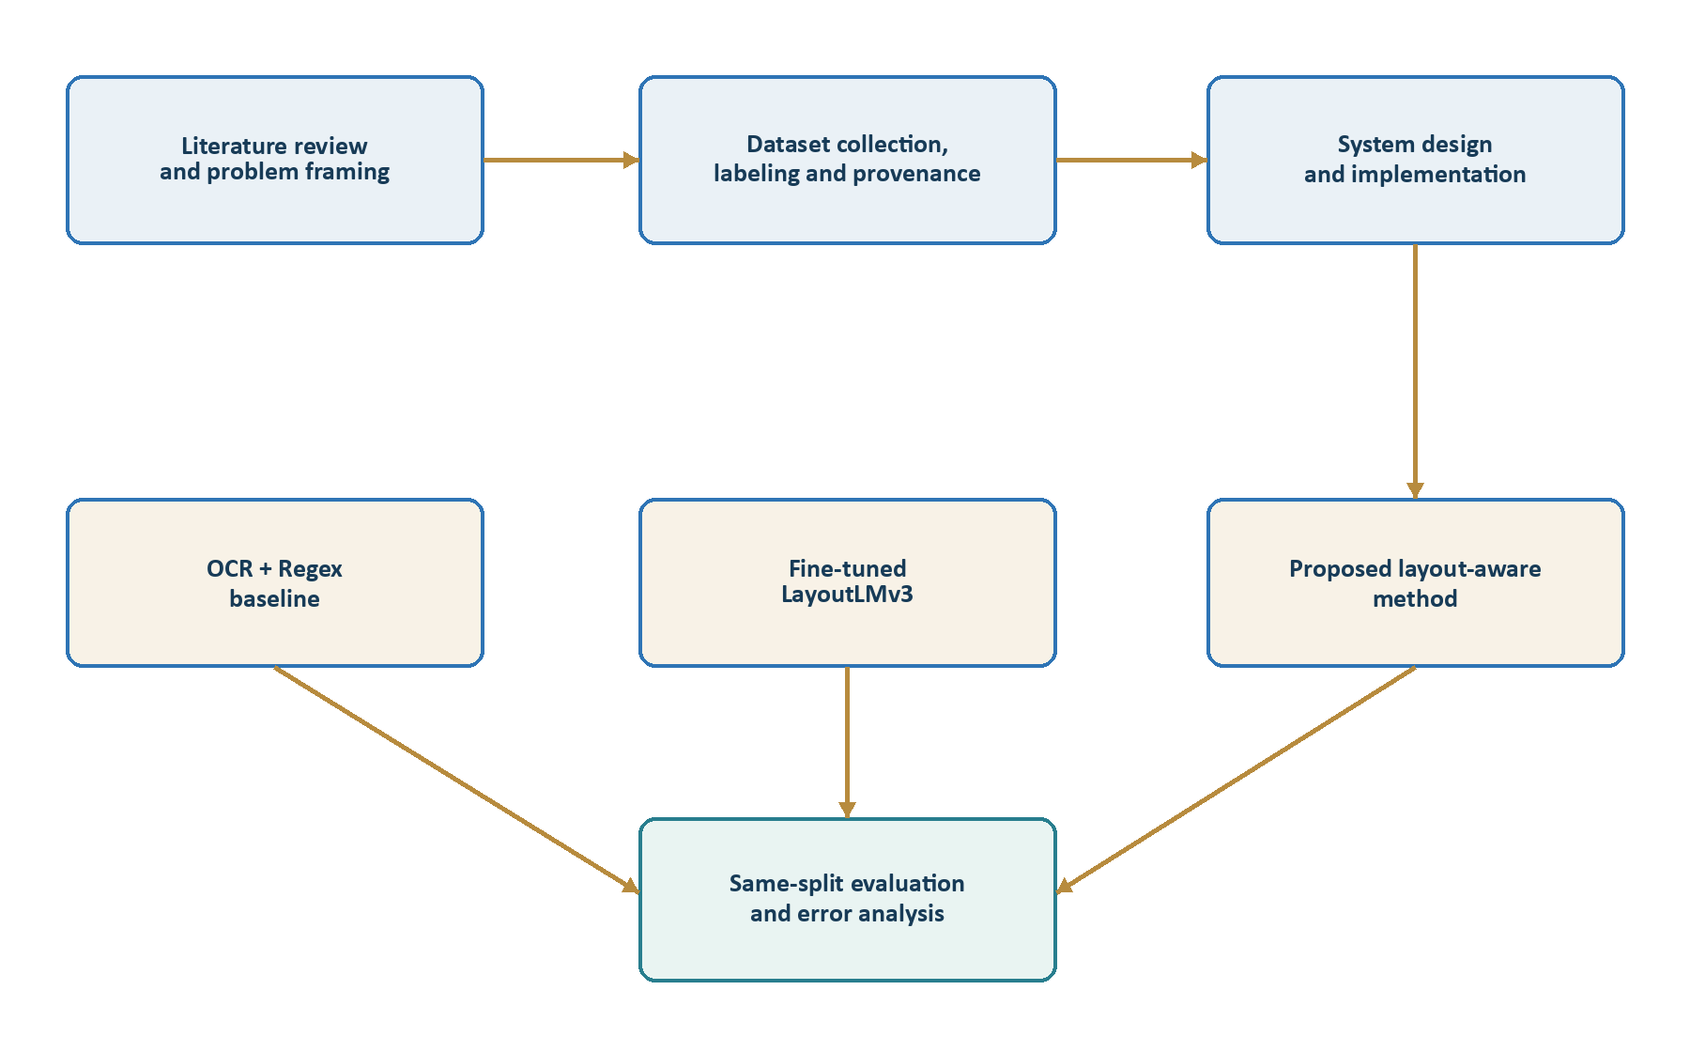
Figure 3.1. Research and implementation workflow

3.2 Requirements Analysis
Table 3.1. Functional and non-functional requirements
Type | Requirement | Verification
Functional | Accept PDF, JPG, JPEG, and PNG documents | Upload form validation and route test
Functional | Produce OCR text, geometry, confidence, and metadata | OCRToken records and evidence output
Functional | Run regex and proposed extraction on the same OCR tokens | Processing view and stored ExtractionResult rows
Functional | Permit correction and approval | Review form and ReviewedInvoice model
Functional | Export approved data as CSV or JSON | Export service and response tests
Non-functional | Explain predictions | Per-field source text, bounding box, method, score, and explanation
Non-functional | Remain reproducible | Pinned requirements, saved model, fixed split, deterministic scripts
Non-functional | Handle heterogeneous documents | Seven categories, multilingual routing, OCR fallback, format priors

3.3 Dataset Construction
The final collection contains 83 labeled documents distributed across Chinese invoices, clean synthetic invoices, English invoices, FATURA invoices, Malaysian invoices and receipts, noisy documents, and VATID Chinese VAT-style invoices. The collection deliberately includes both easy and difficult cases so that the evaluation does not reduce to a single template family. FATURA contributes public synthetic diversity under CC BY 4.0; VATID contributes Chinese VAT-style examples; local project samples add English, Chinese taxi, Malaysian, and noisy receipt cases.
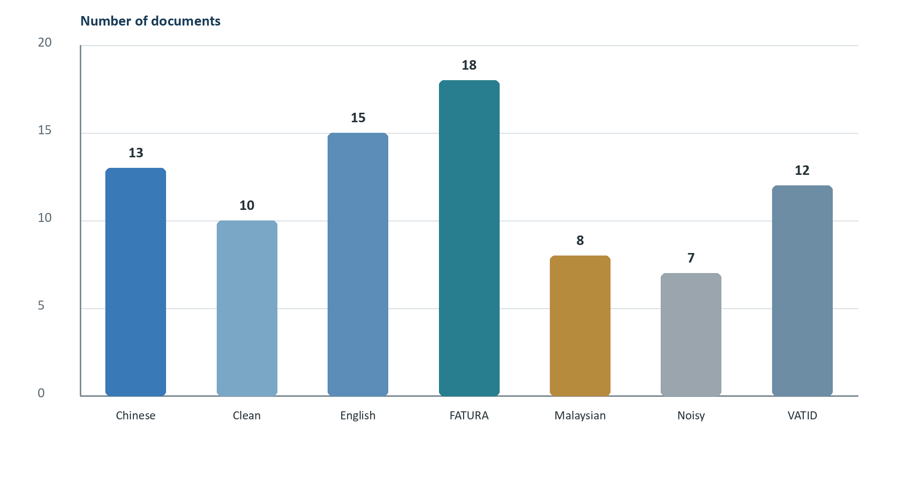
Figure 3.2. Composition of the final 83-document dataset
Source: data/dataset_log.csv and final ground-truth records.
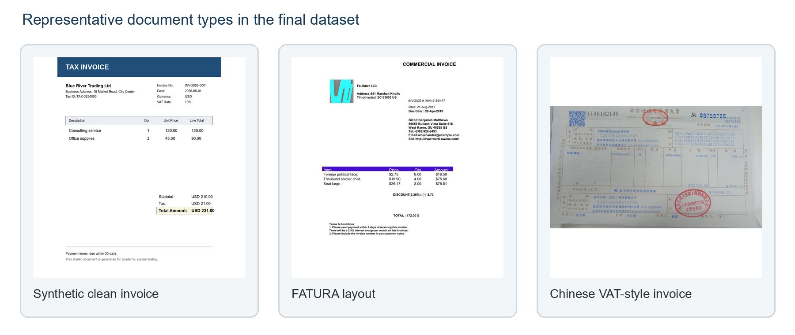
Figure 3.3. Representative document diversity
Examples shown for methodological illustration; document rights remain with their respective sources.
Table 3.2. Final dataset composition and split
Category | Total | Training | Evaluation
Chinese invoices | 13 | 10 | 3
Clean invoices | 10 | 8 | 2
English invoices | 15 | 11 | 4
FATURA | 18 | 14 | 4
Malaysian invoices | 8 | 6 | 2
Noisy invoices | 7 | 5 | 2
VATID | 12 | 9 | 3
Total | 83 | 63 | 20
The stratified split uses seed 42 and contains no train/evaluation overlap.

3.4 Labeling and Provenance
Ground truth was prepared at field level. The final CSV contains one record per document with invoice number, date, vendor name, subtotal, tax amount, total amount, and currency where available. Provenance was retained instead of claiming that every cell was independently typed from a blank form. Sixty-three rows reused existing manual labels, 18 low-confidence or anomalous pre-labeled rows entered a review queue and were corrected, and two layout-aware pre-labels remained review-optional. Those two rows introduce a small risk of bias toward the proposed method. This limitation is disclosed in the results and future-work sections.
Ground-truth integrity
The repository contains 83 label rows, no missing referenced images, no duplicate paths, a 63/20 split, and no train-evaluation overlap. The two retained review-optional pre-labels should nevertheless be independently re-annotated in a future study.

3.5 Compared Methods
- OCR + Regex baseline: line grouping, full-text regular expressions, basic currency matching, and a simple top-region vendor guess.
- Fine-tuned LayoutLMv3 baseline: OCR tokens, normalized 2D bounding boxes, document images, BIO field labels, weighted token-classification loss, and contextual decoding.
- Proposed layout-aware method: OCR token normalization, fuzzy label matching, spatial candidate generation, confidence and format scoring, category routing, financial constraints, and anomaly-aware evidence.

3.6 Evaluation Procedure and Metrics
All three methods were evaluated against the same 20 held-out documents and the same normalization logic. Amounts were normalized to two decimal places; currency aliases such as MYR and RM were mapped consistently; dates were converted to a standard representation; invoice-number whitespace and punctuation were normalized; and vendor comparisons tolerated only minor punctuation or OCR variation. The definitive result package contains 20 documents × 7 fields × 3 methods = 420 field records.
Overall accuracy = correct labeled field predictions / total labeled ground-truth fields
Precision = correct predictions / non-empty predictions; Recall = correct predictions / labeled fields
F1 = 2 × precision × recall / (precision + recall)
A document passes only if invoice number, date, vendor name, total amount, and currency are all correct. The human correction rate is the proportion of documents for which at least one error or anomaly would require review. Because the evaluation set is small, this report adds a document-cluster bootstrap analysis as an exploratory uncertainty estimate. The official micro-accuracy values remain the primary reported metrics.
Table 3.3. Evaluation measures
Measure | Interpretation
Field accuracy | Proportion of labeled values correctly extracted for one field
Overall accuracy | Micro-average across all labeled fields
Precision / recall / F1 | Balance between emitted values and recovered ground truth
Document pass rate | All five required fields correct on a document
Human correction rate | Document requires correction or triggers an anomaly
Recorded time | Observed processing time; not a fully controlled cross-method benchmark
Cluster bootstrap | Document-resampled uncertainty around macro accuracy and paired differences

CHAPTER 4
System Architecture and Design

4.1 Architectural Overview
The system uses a modular pipeline so that OCR, extraction, verification, review, and export can be tested and improved independently. An uploaded document is stored first. OCR then produces token records with page number, text, confidence, and bounding coordinates. The baseline and proposed methods consume the same token list. Predictions, evidence, anomalies, and timing are stored separately by method. The proposed result is presented to the reviewer, and only approved values are exported.
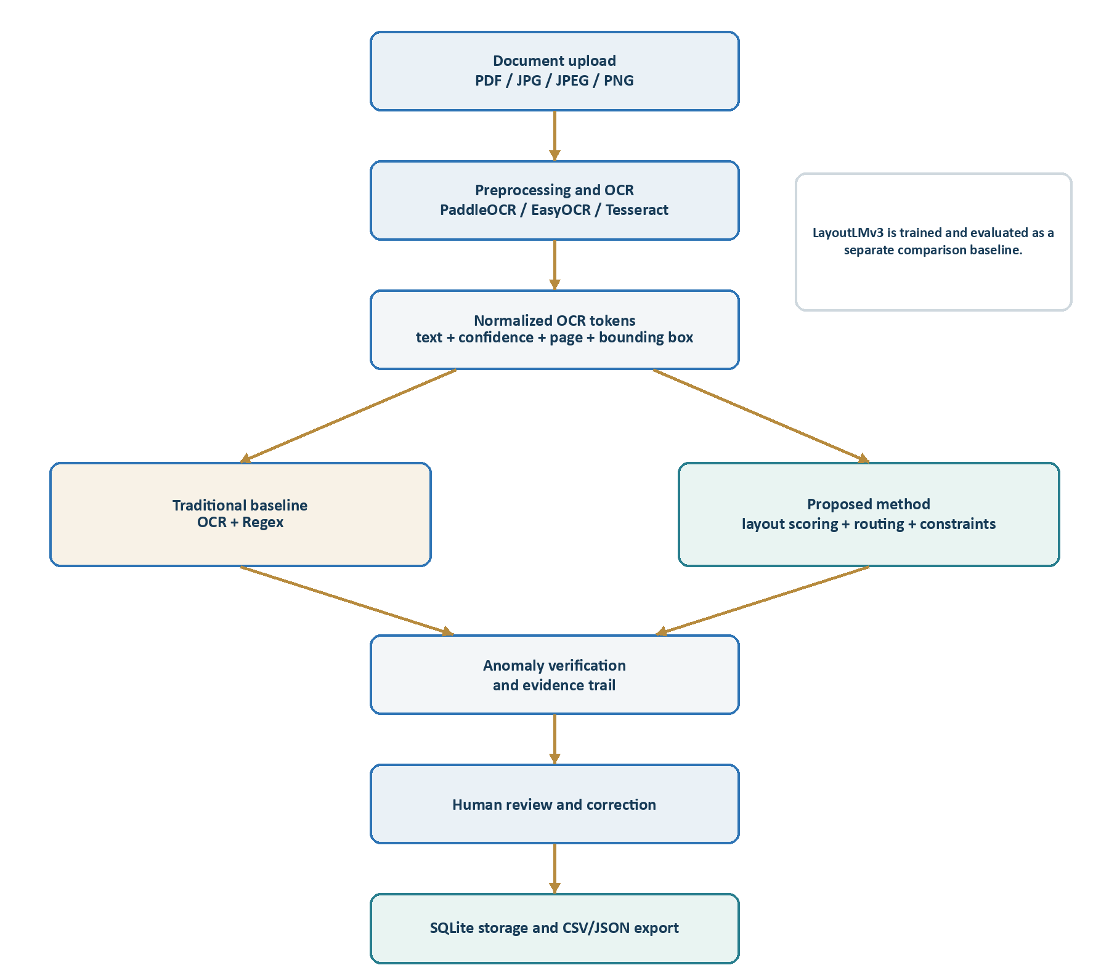
Figure 4.1. End-to-end system architecture

4.2 Application and Service Layers
Table 4.1. Main service modules and responsibilities
Module | Responsibility
preprocessing.py | Image cleanup, denoising, thresholding, contrast enhancement, resizing, and deskew variants
ocr.py | OCR engine selection, GPU handling, retries, language hints, token fusion, cache, and metadata
extraction.py | Regex baseline and proposed layout-aware candidate generation and selection
document_router.py | Lightweight classification into broad document categories
constraint_engine.py | Financial amount evidence and consistent subtotal-tax-total assignments
amount_repair.py | Constrained repairs for damaged amount tokens
anomalies.py | Explainable invoice-specific anomaly checks
layoutlmv3_baseline.py | BIO alignment, token decoding, and contextual field recovery
evaluation.py | Normalization, field metrics, category metrics, pass rate, and output serialization
views.py / models.py | Web workflow, persistence, review, approval, and export coordination

4.3 Data Model
The database design preserves the document lifecycle. InvoiceDocument records the file and status. OCRToken stores the recognized evidence. ExtractionResult stores one method's structured fields, confidences, explanations, anomalies, and timing. ReviewedInvoice stores the human-approved record and reviewer notes. This separation makes it possible to compare automated outputs without overwriting the final human decision.
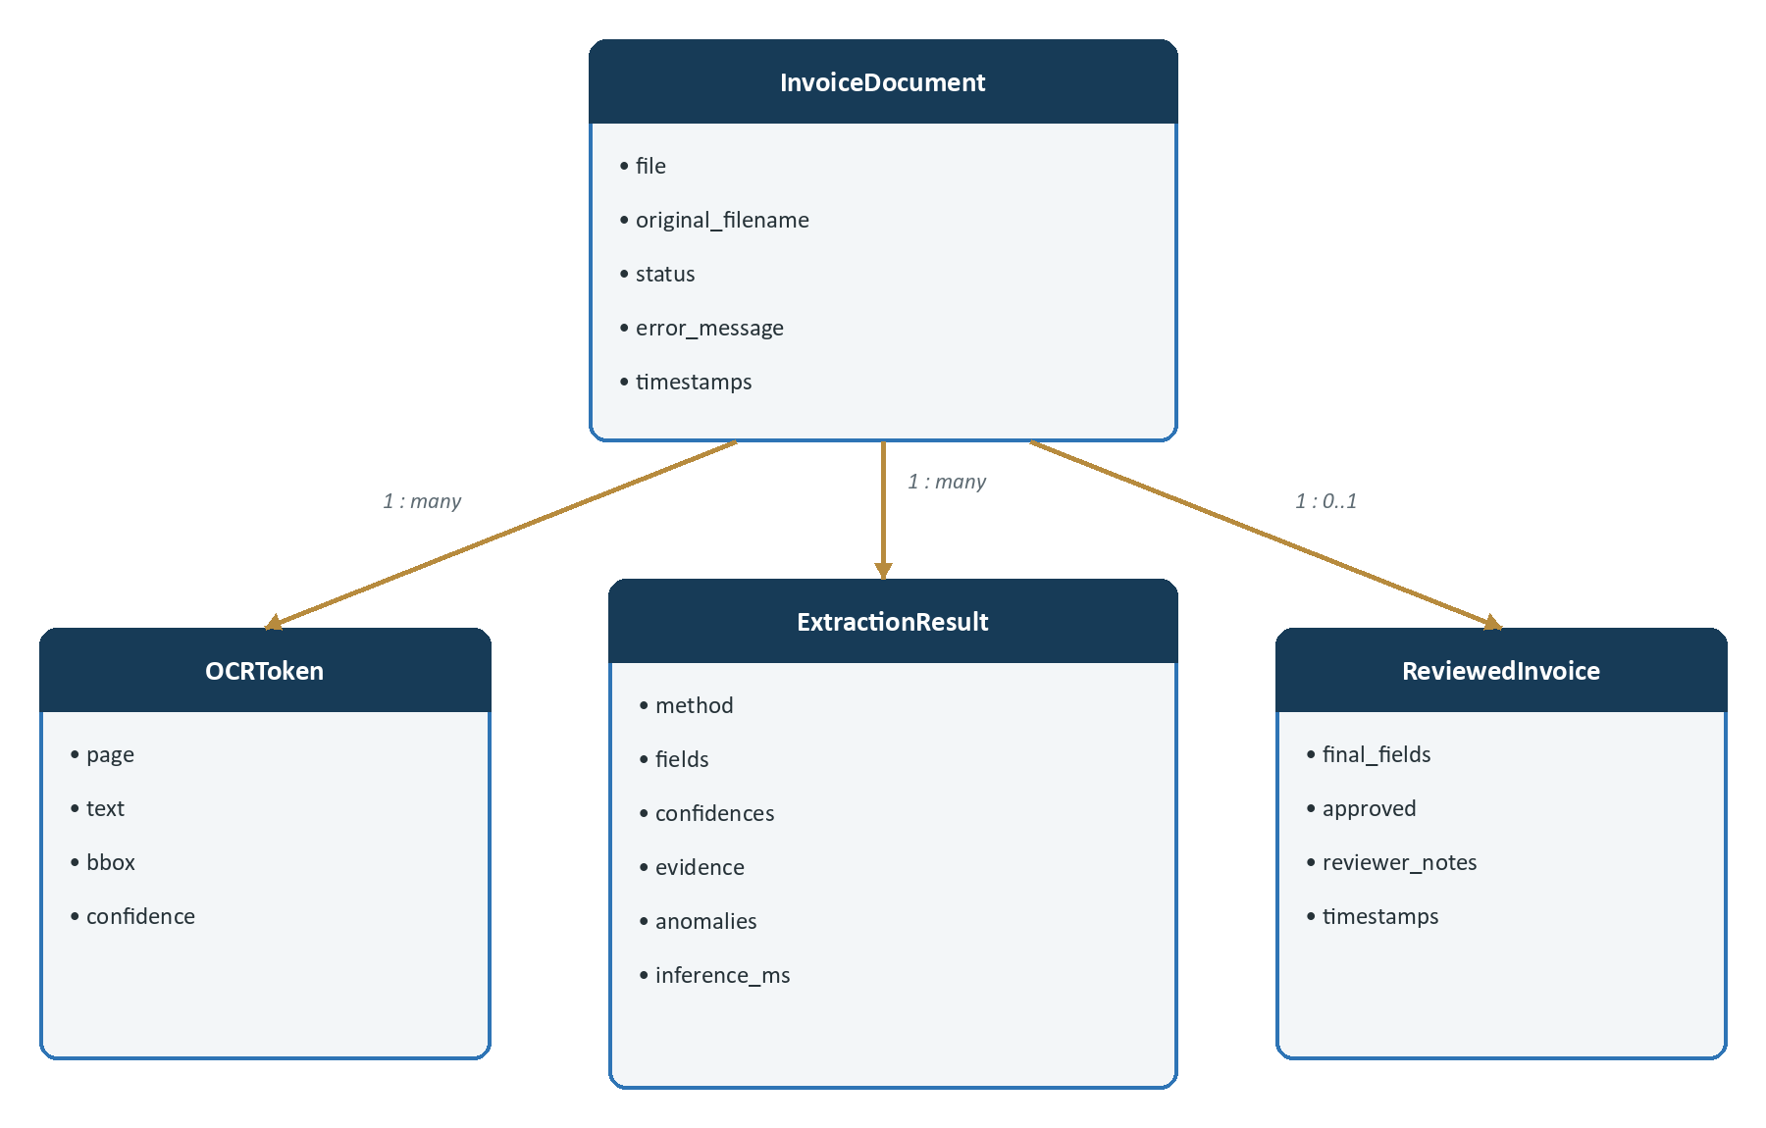
Figure 4.2. Core database entities and relationships

4.4 Human Review and Export Design
The review page is pre-populated from the layout-aware extraction because it is the primary proposed method. The user can correct invoice number, date, vendor, tax, total, and currency, add notes, and approve the record. Export is intentionally blocked until a ReviewedInvoice exists. This design prevents an unreviewed machine output from being presented as the final accounting record.

4.5 Explainability and Failure Containment
Each selected field retains its source text, source bounding box, selection method, confidence, explanation, and where relevant an amount role. OCR run metadata records the selected engine, languages, attempted fallbacks, preprocessing variants, and cache state. The design therefore provides two levels of traceability: why the OCR token exists and why the extractor chose it. Anomaly rules then contain failures by surfacing suspicious outputs before approval.

CHAPTER 5
System Implementation

5.1 Technology Stack
Table 5.1. Final technology stack
Area | Final implementation
Language and framework | Python 3.12, Django 5.2.15
Database and interface | SQLite, server-rendered HTML/CSS templates
OCR | PaddleOCR 3.7.0, EasyOCR 1.7.2, optional Tesseract
Image processing | OpenCV 4.10, Pillow 12.2, pdf2image
Deep learning | PyTorch 2.5.1 CUDA 12.1, Transformers 4.46.3, LayoutLMv3-base
Paddle runtime | PaddlePaddle GPU 3.3.1 with CUDA 12.6 packages
Outputs | SQLite records, JSON evidence, CSV/JSON exports, CSV/JSON experiment summaries
Operating environment | Windows with NVIDIA GPU

5.2 Image Preprocessing and OCR
The preprocessing service creates several alternatives rather than assuming that one transform is universally best. Available variants include background cleaning, grayscale, denoising, histogram equalization, CLAHE, Otsu thresholding, adaptive thresholding, two-times resizing, sharpening, limited deskewing, and raw upscaling. Resolution can be capped to prevent excessive GPU memory use.
The final OCR path prefers PaddleOCR and can retry with EasyOCR when token quantity or quality is poor. Language selection uses file and content hints, with additional Chinese handling when a document resembles a Chinese invoice. Paddle variants may be fused so that conflicting but useful tokens are not lost. Tokens are cached using a key that includes the file hash and OCR settings, which improves repeatability and avoids unnecessary reprocessing. Tesseract remains an optional fallback.

5.3 OCR + Regex Baseline
The traditional baseline groups tokens into lines, joins them into full OCR text, and applies regular expressions for invoice number, date, tax, subtotal, total, VAT rate, amount in words, and currency. A top-region heuristic provides a basic vendor guess. The baseline deliberately does not use the full financial constraint or routing logic. It therefore represents the kind of straightforward OCR application that is easy to build but vulnerable to label corruption and layout variation.

5.4 Proposed Layout-Aware Extraction
The proposed method begins by normalizing OCR text while preserving the original token, geometry, and confidence. Tokens are grouped into lines using y-center proximity and vertical overlap, then sorted from left to right. Fuzzy canonicalization corrects recurring label errors such as INWWICE, Tote], Rourding, and CWaNGE. Candidate contexts are collected from text on the same line, text immediately to the right, and nearby lines when another strong label does not mark a boundary.
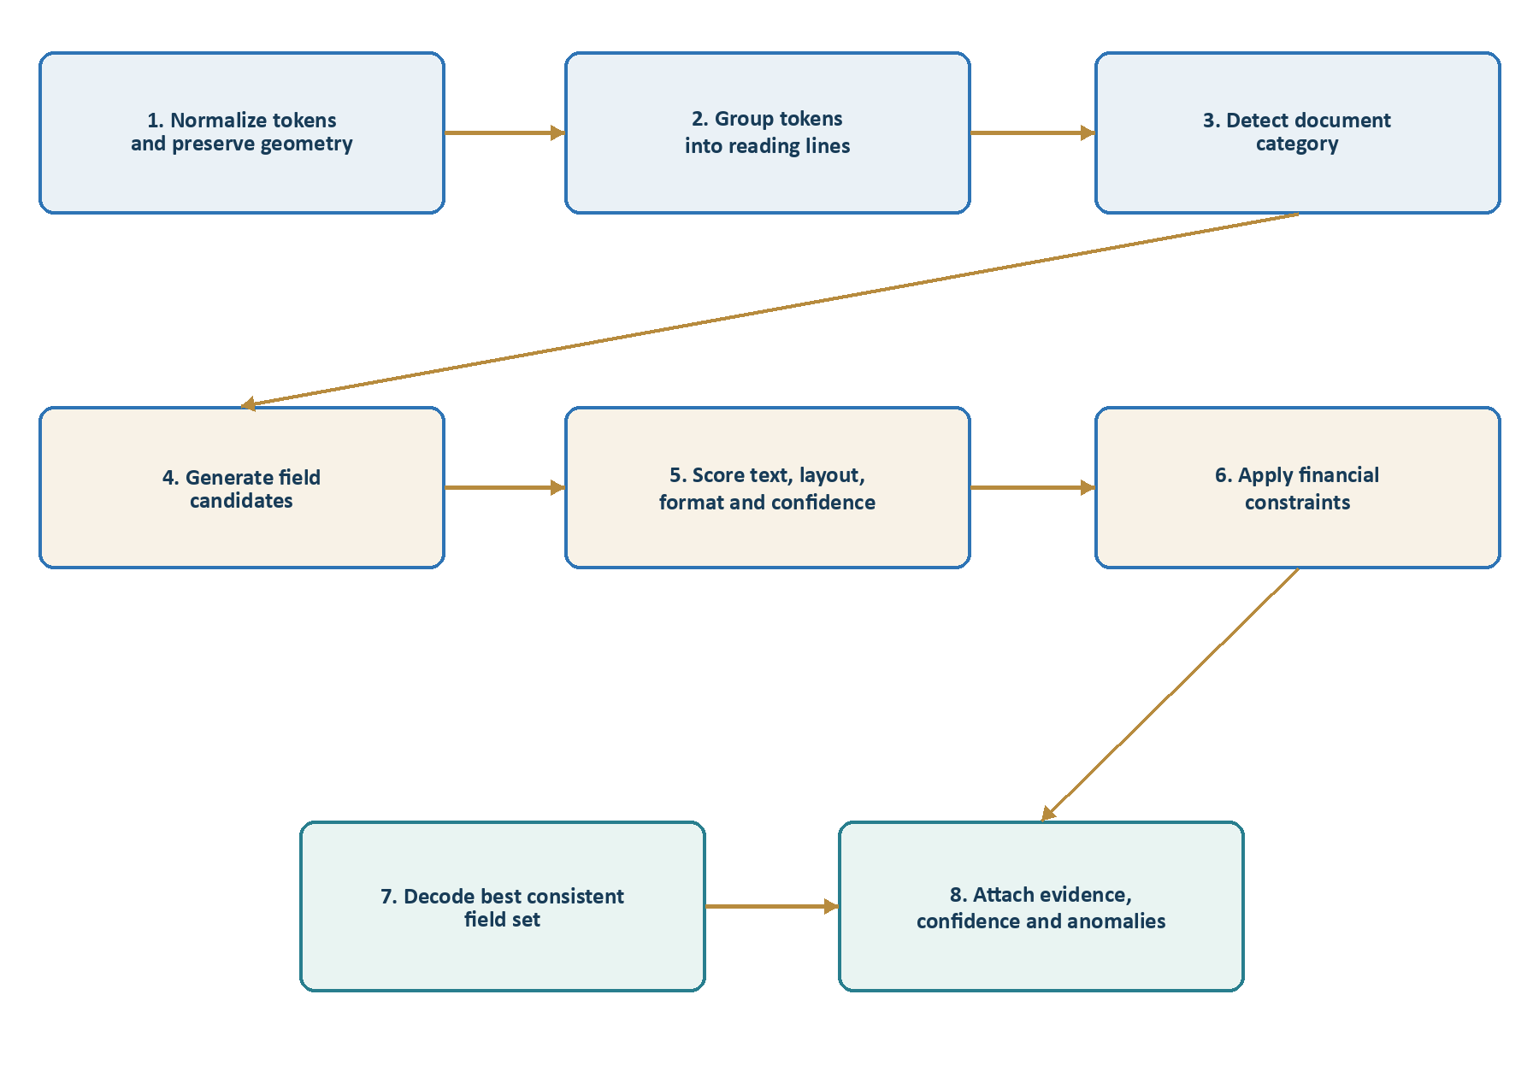
Figure 5.1. Proposed layout-aware extraction pipeline
Candidate scores combine several interpretable signals. OCR confidence rewards legible evidence. Label strength and proximity reward values that are spatially linked to a relevant field name. Format validation rejects dates as invoice numbers and percentages as tax amounts. Document-region priors favor vendor names near the top and totals in financial summary regions. Negative anchors penalize addresses, buyer blocks, line items, savings, cash, change, and unrelated identifiers. The selected evidence remains available to the user and anomaly engine.
Table 5.2. Proposed method scoring evidence
Evidence type | Example effect
OCR confidence | Higher-quality tokens receive stronger support.
Label relationship | A value immediately right of 'Invoice No' is preferred.
Spatial region | Top-region text can support vendor; lower summary text can support total.
Format validity | Date-like strings are rejected as invoice numbers.
Negative context | Cash, change, discount, quantity, address, tax ID, and payment lines are penalized.
Document route | Chinese, Malaysian, FATURA, clean, and noisy profiles adjust candidate priors.
Financial consistency | Subtotal + tax ≈ total and cash - total ≈ change support coherent assignments.
Format-specific prior | Chinese VAT and taxi layouts can use label and meter-row patterns.

5.5 Financial Constraint Engine
Financial values cannot be interpreted independently. A receipt may contain subtotal, tax, total, cash tendered, change, discounts, savings, and line-item prices. The constraint engine first classifies amount evidence by nearby labels and document zone. It then searches for assignments satisfying practical laws, including subtotal plus tax approximately equaling total, cash being no less than total, cash minus total approximately equaling change, and the total appearing below the item body. Hard violations, such as tax greater than or equal to total, are rejected.
The same mechanism supports conservative OCR repair. A damaged amount token is not corrected merely because one character resembles a digit. Alternative repairs are admitted with reduced confidence and selected only when they participate in a stronger financial assignment. This approach recovered difficult cases such as the 99 SPEED MART receipt in which cash 200.00 had initially been mistaken for both tax and total.

5.6 Document Routing and Multilingual Handling
A lightweight router scores broad categories using CJK character presence, Chinese invoice terms, RM/MYR and Malaysian business cues, FATURA/KDV terms, clean invoice labels, receipt cues, and OCR-noise indicators. Routing changes priors rather than replacing field evidence, so an imperfect route does not force a fixed parser. Chinese VAT, taxi, and retail receipt profiles have specialized candidate logic; Malaysian receipts receive RM and cash-change handling; FATURA documents receive KDV and Turkish invoice cues.

5.7 Anomaly Verification
Table 5.3. Explainable anomaly rules
Rule | Purpose
Missing required field | Prevents incomplete records from appearing complete.
Duplicate invoice number | Flags a number already present in approved records.
Invalid or future date | Detects malformed or temporally impossible invoice dates.
Tax ≥ total | Rejects an implausible amount-role assignment.
Subtotal + tax mismatch | Checks the principal invoice arithmetic identity.
Cash-change mismatch | Checks whether cash paid minus total equals change.
Payment-line total/tax | Uses extraction evidence to detect cash selected as a financial field.
Line-item mismatch | Checks quantity × unit price against line total when data exist.
Low-confidence key field | Directs human attention to uncertain required values.
Unsupported currency / amount words | Flags unfamiliar codes or basic numeric-text inconsistency.

5.8 LayoutLMv3 Baseline
The deep-learning baseline uses microsoft/layoutlmv3-base for token classification. OCR tokens are converted into words with normalized bounding boxes in the 0-1000 LayoutLM coordinate range. Ground-truth field values are aligned to token spans and encoded with BIO labels. Because the O class dominates the 63 training examples, weighted loss reduces its influence and caps minority-class weights. Training ran for five epochs with a maximum sequence length of 512.
Currency label coverage fell below the preparation threshold because OCR frequently merged a symbol and amount inside one token, causing span overlap with amount labels. Training continued as a documented limitation. A contextual decoder cleans predicted spans, strips field labels, repairs amount and date formats, detects document currency, and searches nearby values when the model labels a field marker rather than its value.
Table 5.4. LayoutLMv3 training configuration
Parameter | Value
Base model | microsoft/layoutlmv3-base
Training / evaluation examples | 63 / 20
Epochs | 5
Maximum sequence length | 512
Label schema | O plus B-/I- labels for seven fields
Loss | Weighted token-classification loss
O-class weight | 0.15
Maximum minority-class weight | 8.0
Saved artifact | models/layoutlmv3_baseline_v2

5.9 Testing and Verification
Testing evolved with the system. Early tests covered basic extraction and anomalies. Later regression fixtures captured invoice-number/date confusion, damaged amount repair, multi-line vendors, Chinese VAT headers, taxi-meter rows, Malaysian cash/change receipts, routing, OCR fallback, cache behavior, variant fusion, and evidence storage. The final suite contains 38 core tests and 106 regression tests.
Table 5.5. Verification and test coverage
Verification area | Final status
Automated tests | 144 passed
Django system check | No issues
Migration check | No pending changes
Dashboard, upload, and detail routes | HTTP 200
Dependency consistency | pip check passed
LayoutLMv3 artifact | Processor and model load locally
PyTorch CUDA | Available
PaddleOCR GPU | Reader initialized on gpu:0
Dataset integrity | 83 rows, no missing files, duplicates, or split overlap
Comparison integrity | 420 field records on the same 20 documents
Verified final repository status, June 18, 2026.

CHAPTER 6
Development Challenges and Iterative Improvements

6.1 Development as Failure-Driven Engineering
The final method was not designed in one pass. It emerged from repeatedly comparing the extracted evidence with the source image and identifying why a plausible but wrong candidate won. This was especially important because mocked OCR tokens often looked cleaner than real OCR output. The project therefore moved from generic tests to stored token fixtures and category-specific regression cases.
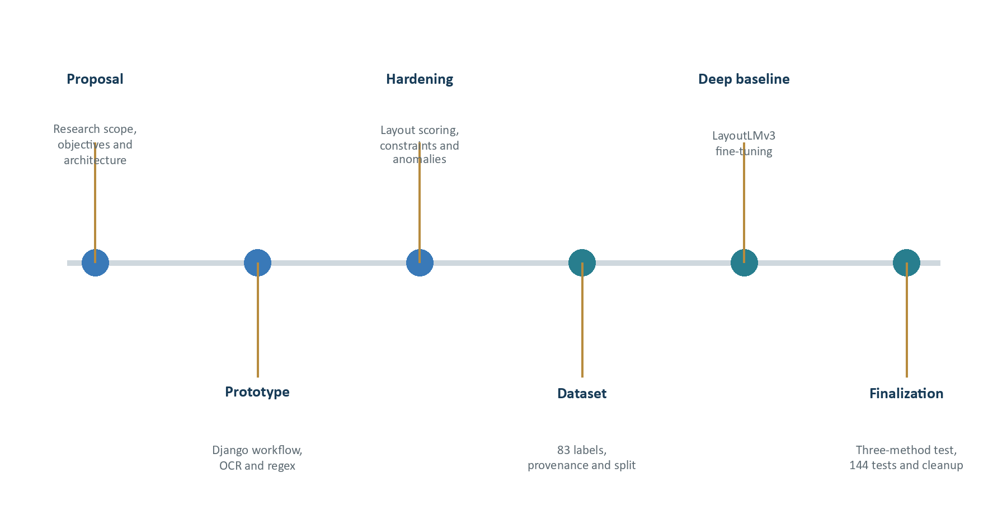
Figure 6.1. Iterative development and validation timeline

6.2 OCR Quality and Variant Selection
Thermal receipts, colored backgrounds, skew, and low contrast caused missing or merged tokens. A single aggressive preprocessing recipe sometimes improved one line while destroying another. The solution was a collection of variants, quality scoring, selective retry, and token fusion. The OCR layer also records which variant produced each retained token, making later errors diagnosable.

6.3 Invoice Number Confused with Date
One stored receipt contained 'Involce Nlo:: CS67332' followed by a date line. The extractor correctly found CS67332 but allowed its next-line search to cross into 'Date 22/12/2017'; the date scored slightly higher and became both invoice number and date. The fix added broader date-pattern rejection, stopped contexts at new labels, and rewarded immediate same-line values. Regression tests now assert that the two fields remain distinct.

6.4 Cash Selected as Tax and Total
In the 99 SPEED MART example, OCR produced a noisy GST Summary heading, split tax '9 61', and rendered the total as '169,80' or the more damaged 'J89,80'. Cash 200.00 was visually clear and initially dominated both tax and total. The implementation introduced noisy GST/SST recognition, spaced-decimal repair, comma-decimal normalization, payment-context penalties, explicit amount roles, anomaly checks, and finally a constrained repair pool. The financial laws selected subtotal 160.47, tax 9.61, and total 169.80 when the evidence supported them.

6.5 Vendor Name Extraction
Vendor names remain difficult because several organizations may appear on one page. Logos may not OCR cleanly, while addresses, tax authorities, buyer names, branch names, registration numbers, emails, bank details, and product lines all compete for the top region. Early logic selected only one line and therefore truncated names ending with an ampersand or promoted address fragments. Later revisions added multi-line assembly, business-suffix signals, address and contact penalties, buyer/seller disambiguation, Chinese seller-block parsing, repeated-text collapse, and government-preamble removal. Despite these improvements, vendor accuracy remains below the other required fields.

6.6 Multilingual and Format-Specific Cases
Chinese VAT invoices may contain tax bureau text, buyer and seller tables, tax identifiers, invoice codes, invoice numbers, amount-in-words, and repeated printer text. Taxi invoices use meter-row patterns that differ from formal VAT forms. Malaysian receipts rely on RM, GST/SST, cash, change, rounded total, and noisy business suffixes such as S/B. FATURA invoices introduce KDV and Turkish labels. Generic rules alone were insufficient, so the system uses format profiles and category routing while preserving a shared candidate-scoring framework.

6.7 Small-Data LayoutLMv3 Training
The Transformer baseline faced class imbalance, sparse I-labels, token-ground-truth alignment failures, and mixed document layouts. The dominant O label appeared 4,443 times in training, while several I labels appeared zero or once. Weighted loss, tolerant span matching, OCR-confusion variants, and contextual decoding improved usability, but the model still struggled with vendor names and invoice numbers. This was not treated as a failed experiment; it became evidence that strong pre-trained models still need adequate task-specific supervision.
Table 6.1. Major engineering challenges, causes, and remedies
Challenge | Root cause | Implemented remedy
Low-quality OCR | Faint print, skew, backgrounds, merged or split tokens | Multi-variant preprocessing, retry, fusion, language hints, cache
Invoice number becomes date | Next-line context crossed a new label | Date rejection, context boundary, same-line preference
Cash becomes total/tax | Strong payment amount outscored damaged summary values | Amount roles, payment penalties, anomalies, financial constraints
Damaged amount token | Letter-digit confusion such as J89,80 | Limited repair alternatives selected only through consistency
Vendor/address confusion | Multiple organizations and noisy top-region lines | Multi-line assembly, suffix signals, blocklists, buyer/seller logic
Chinese and Malaysian variation | Different scripts, labels, tax and payment conventions | Category routing and format-specific priors
LayoutLMv3 imbalance | Small data and dominant O label | Weighted loss, tolerant alignment, contextual decoder
CUDA coexistence | PyTorch and PaddlePaddle DLL conflicts on Windows | Controlled import path, GPU smoke tests, pinned environment

CHAPTER 7
Experimental Results and Analysis

7.1 Evaluation Setup
The final comparison uses the 20-document LayoutLMv3 evaluation split for all three methods. Rule-based methods use PaddleOCR tokens; LayoutLMv3 uses the saved model predictions generated from the prepared examples. All outputs are compared with the same field normalization. Required document-pass fields are invoice number, date, vendor name, total amount, and currency.
Table 7.1. Overall same-split comparison
Method | Overall accuracy | Document pass | Human correction | Recorded ms
OCR + Regex | 33.33% | 0.00% | 100.00% | 26.97
Fine-tuned LayoutLMv3 | 58.91% | 5.00% | 95.00% | 96.08
Proposed layout-aware method | 75.97% | 35.00% | 70.00% | 2749.18
Accuracy is the primary fair comparison. Recorded time is not controlled equivalently across methods.
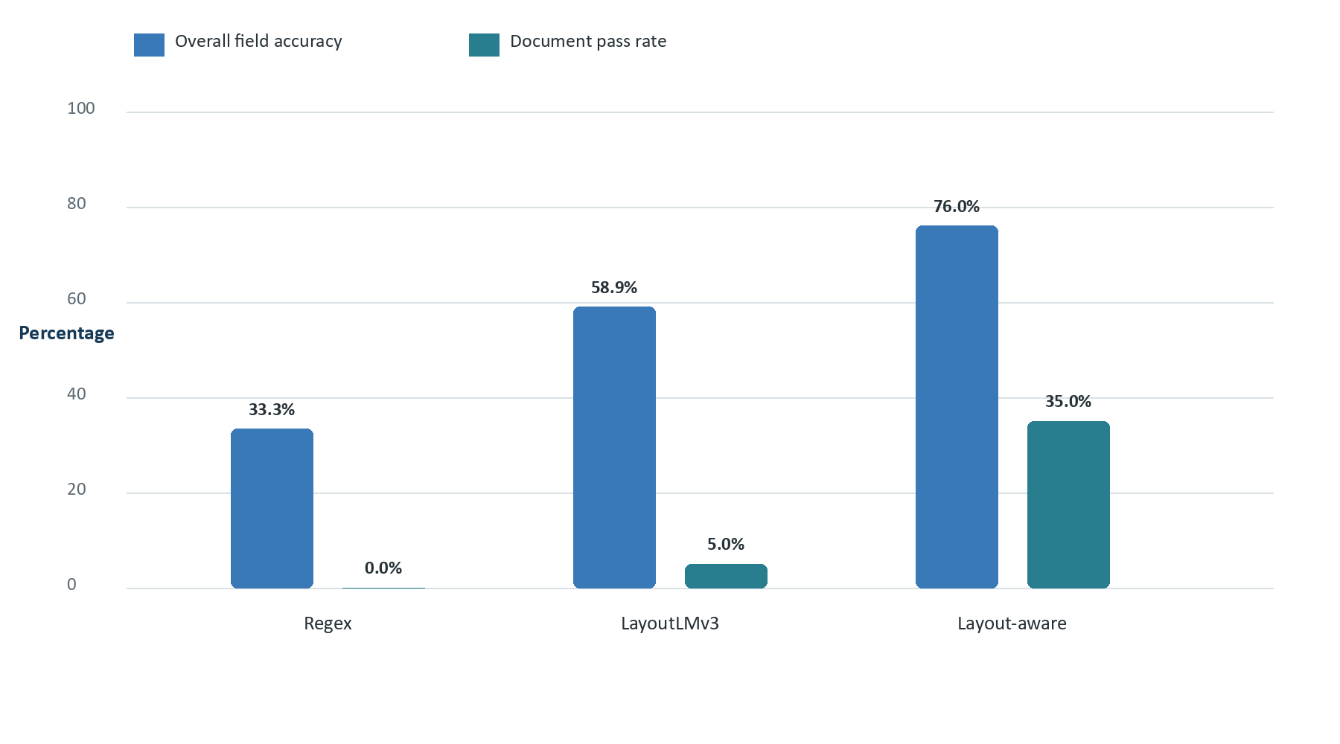
Figure 7.1. Overall accuracy and document pass rate
The proposed method improves over OCR + Regex by 42.64 percentage points and over LayoutLMv3 by 17.06 percentage points in official micro-accuracy. Its document pass rate is seven times the LayoutLMv3 rate and is the only method to produce more than one fully correct required-field record. Nevertheless, 70% of documents still require some human correction, which confirms that the review stage remains necessary.
Table 7.2. Field-level accuracy
Field | OCR + Regex | LayoutLMv3 | Layout-aware
Invoice number | 55.00% | 55.00% | 90.00%
Date | 10.00% | 85.00% | 85.00%
Vendor name | 21.05% | 10.53% | 47.37%
Subtotal | 26.67% | 53.33% | 60.00%
Tax amount | 0.00% | 46.67% | 73.33%
Total amount | 15.00% | 60.00% | 80.00%
Currency | 95.00% | 95.00% | 90.00%
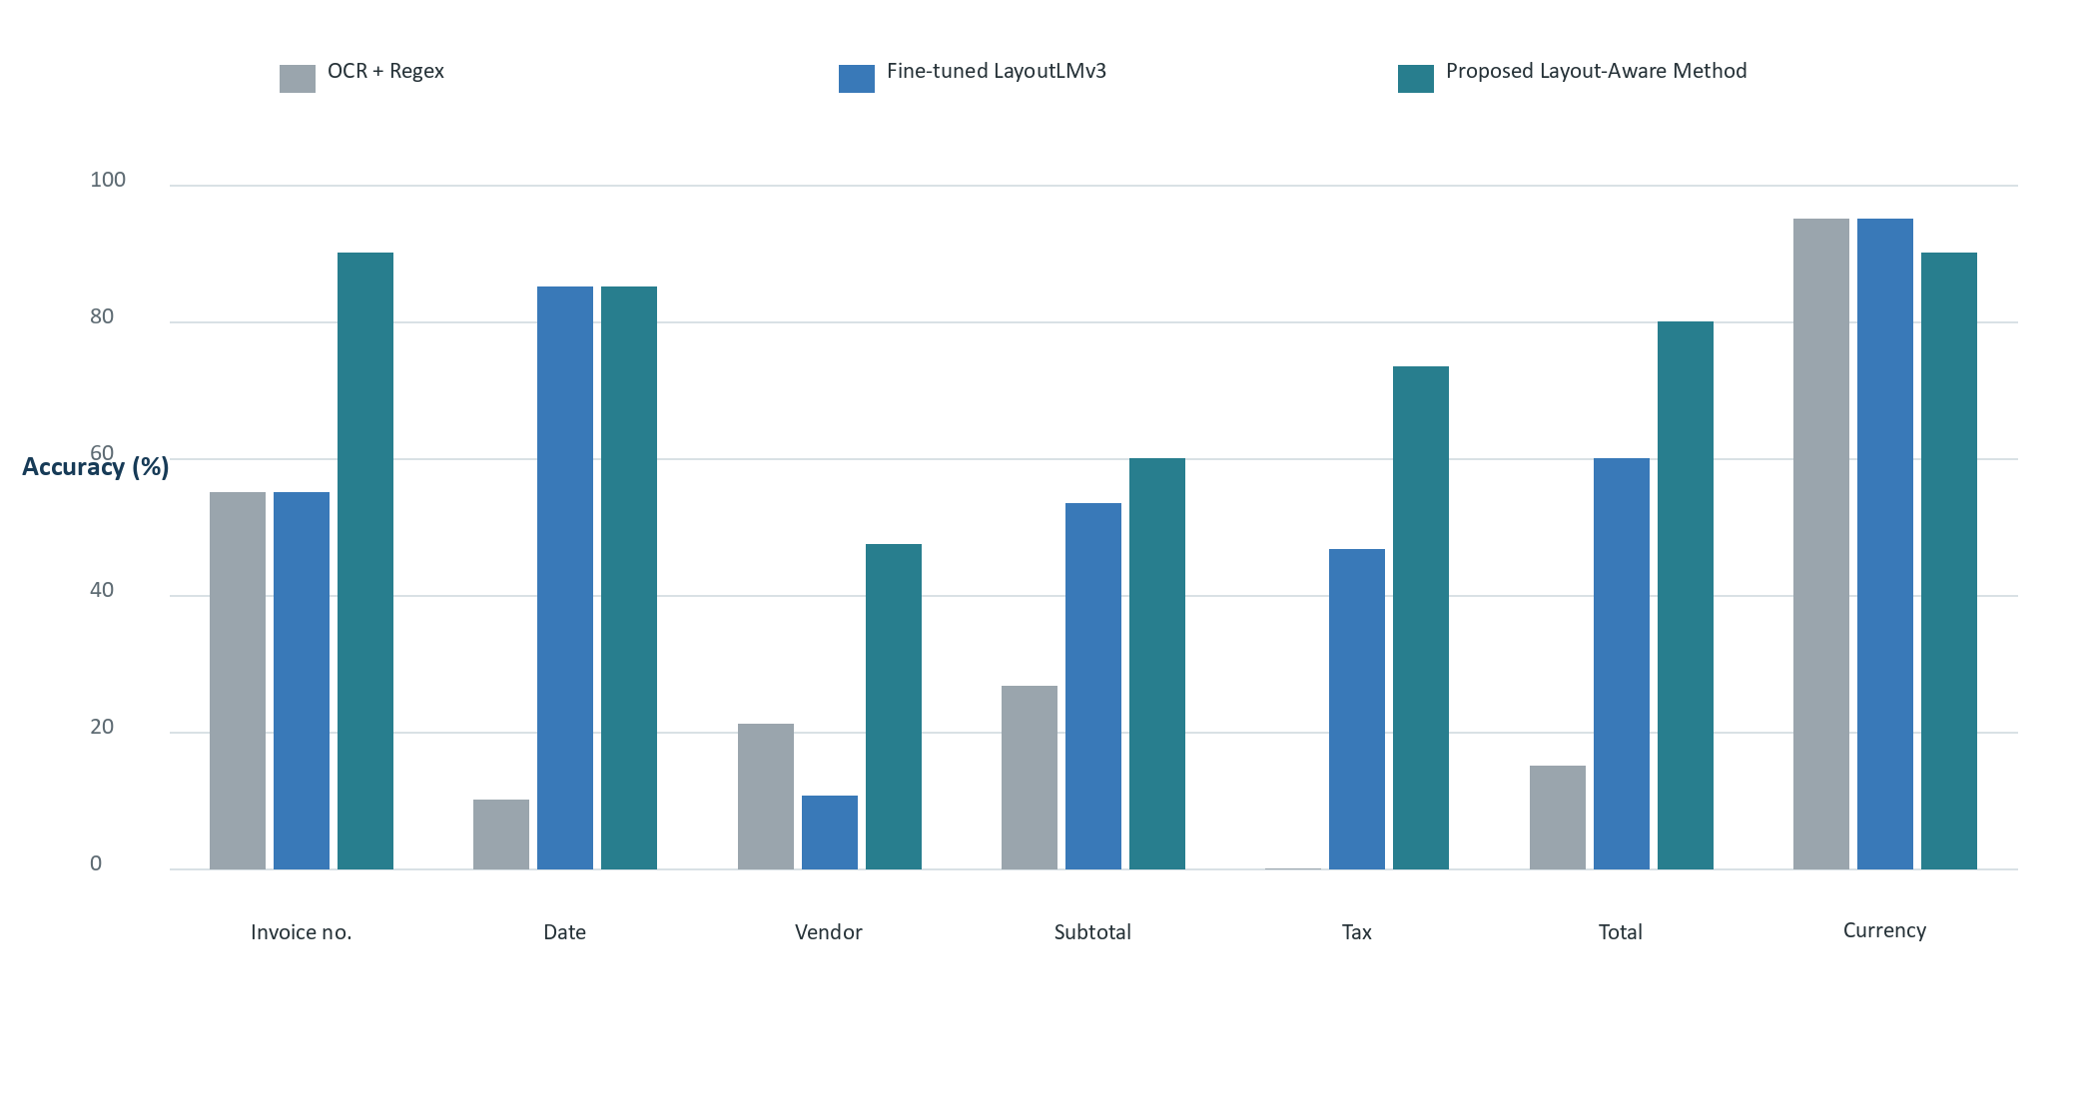
Figure 7.2. Field-level accuracy by method
Invoice number and financial fields show the clearest benefit from explicit layout and business logic. The proposed method reaches 90% on invoice number, 73.33% on tax, and 80% on total. LayoutLMv3 equals the proposed method on date and exceeds regex substantially on subtotal, tax, and total. Currency is the only field where regex and LayoutLMv3 slightly exceed the proposed method, mainly because the proposed extractor abstains when currency evidence falls below a confidence floor. Vendor name is weak for every method and is especially poor for LayoutLMv3.
Table 7.3. Category-level accuracy
Category | Docs | OCR + Regex | LayoutLMv3 | Layout-aware
Chinese invoices | 3 | 20.00% | 53.33% | 93.33%
Clean invoices | 2 | 71.43% | 92.86% | 100.00%
English invoices | 4 | 25.00% | 67.86% | 42.86%
FATURA | 4 | 46.15% | 61.54% | 76.92%
Malaysian invoices | 2 | 28.57% | 42.86% | 57.14%
Noisy invoices | 2 | 36.36% | 54.55% | 100.00%
VATID | 3 | 14.29% | 38.10% | 90.48%
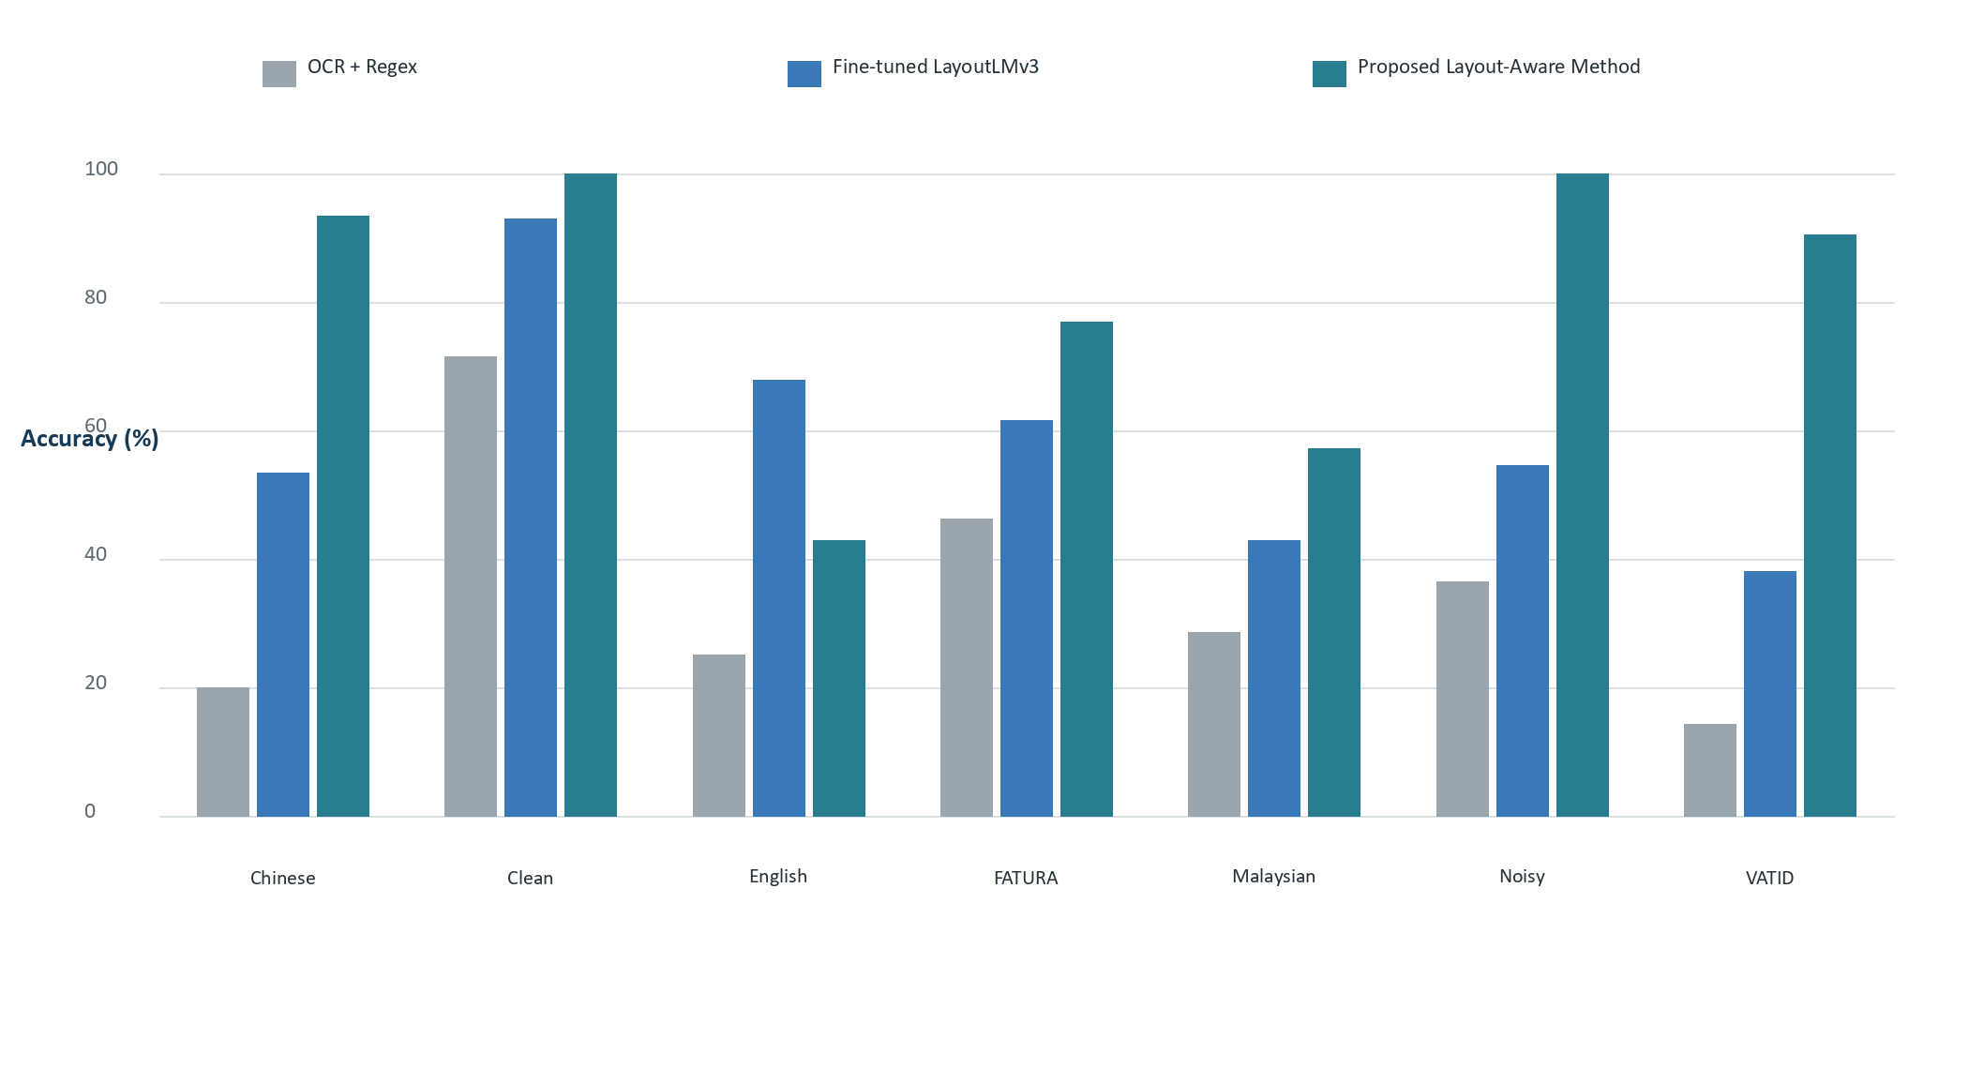
Figure 7.3. Category-level accuracy by method
The proposed method is strongest on clean, noisy, Chinese, VATID, and FATURA subsets. The gains on Chinese and VATID documents correspond to specialized label aliases, seller-table handling, date repair, and invoice-number priors. The perfect noisy-category result should not be generalized because only two noisy documents occur in the evaluation split. LayoutLMv3 is clearly stronger on the four English invoices, suggesting that the proposed English vendor/header and date rules remain less mature than its Chinese and format-specific logic.

7.2 Exploratory Uncertainty Analysis
Table 7.4. Document-cluster bootstrap analysis
Quantity | Estimate | 95% bootstrap interval
OCR + Regex macro accuracy | 32.96% | 25.43%–41.43%
LayoutLMv3 macro accuracy | 59.32% | 49.36%–69.29%
Layout-aware macro accuracy | 77.29% | 67.14%–87.14%
Layout-aware minus Regex | 44.36 pp | 33.00–55.96 pp
Layout-aware minus LayoutLMv3 | 18.05 pp | 2.68–32.43 pp
20,000 document-level bootstrap resamples, fixed seed 42. This is exploratory because n = 20.
The document-macro accuracy differs slightly from official micro-accuracy because each document receives equal weight regardless of the number of labeled fields. The layout-aware method wins against LayoutLMv3 on 14 documents, ties on three, and loses on three; it wins against regex on 19 and ties on one. The paired bootstrap interval for the layout-aware advantage over LayoutLMv3 remains above zero, which supports the observed improvement. It should not be treated as a definitive population-level significance claim because the sample is small, category counts are uneven, and two labels retain potential method-related bias.

7.3 Error Analysis
Table 7.5. Error concentration and interpretation
Area | Observed pattern | Interpretation
Vendor name | 47.37% proposed accuracy; weakest required field | Multiple organizations, logos, addresses, and buyer/seller ambiguity remain difficult.
English category | LayoutLMv3 67.86% vs proposed 42.86% | Learned English patterns outperform current generic English rules on this split.
Currency abstention | Proposed 90% vs 95% for both baselines | Confidence gating avoids unsupported currency but creates some misses.
Document pass rate | 35% despite 75.97% field accuracy | One vendor or total error causes the whole document to fail.
Timing | Proposed recorded time much larger | Rule-based values include OCR; LayoutLMv3 timing is saved model prediction only.
Small categories | Some categories contain only two or three evaluation documents | Category percentages are descriptive and unstable.

CHAPTER 8
Discussion

8.1 Interpretation of the Main Finding
The central result is not that rule systems are generally superior to Transformers. It is that, for this small and heterogeneous dataset, a carefully engineered hybrid method used the available evidence more effectively than either full-text regex or limited fine-tuning. LayoutLMv3 learned useful date, currency, and amount patterns, but the proposed method could explicitly represent constraints that were rare in the training data. For example, it could reject cash as total, demand a coherent subtotal-tax-total triplet, and route Chinese VAT and Malaysian receipt formats to stronger priors.
This finding is consistent with hybrid literature showing that rule-based correction can improve learned KIE outputs (Arroyo et al., 2022) and with practical benchmark research emphasizing domain-specific requirements that generic document tasks often omit (Skalický et al., 2022). It also reflects the limitation emphasized by the business-document literature: real invoices are sensitive, diverse, and difficult to annotate at the scale expected by modern deep learning.

8.2 Explainability and Human Oversight
The proposed method offers an operational advantage beyond accuracy. Its field evidence can state that a total was selected from a lower-page 'Grand Total' line, or that a financial assignment satisfied subtotal-plus-tax and cash-change laws. A reviewer can inspect the source text and bounding box rather than confronting an unexplained value. Confidence gating and anomaly detection reduce the risk of silent acceptance. The 70% correction rate also shows why this oversight is not cosmetic: the system remains an assistant, not an autonomous accountant.

8.3 Achievement of Objectives and Research Questions
Table 8.1. Answers to the research questions
Research question | Evidence-based answer
RQ1: improvement over regex | Yes. Overall accuracy rose from 33.33% to 75.97%, a gain of 42.64 percentage points.
RQ2: comparison with LayoutLMv3 | The proposed method exceeded 58.91% by 17.06 points on the same split, while LayoutLMv3 remained better on English invoices.
RQ3: role of rules and review | Financial constraints removed payment-role errors; anomalies and approval prevent unreviewed output from becoming final data.
RQ4: remaining difficulty | Vendor name is the main weakness; generic English layouts, ground-truth scale, and controlled timing also need work.

8.4 Practical Significance
The completed prototype demonstrates a realistic processing route for small organizations that cannot build a large foundation model or purchase a full enterprise platform. A user can upload a document, compare a weak and improved method, inspect anomalies, correct the result, and export an approved record. The modular code allows future replacement of individual OCR engines, candidate rules, models, databases, or user interfaces without discarding the workflow.

8.5 Theoretical and Methodological Significance
Methodologically, the project demonstrates that document structure can be represented at several levels: token coordinates, line grouping, label-value neighborhoods, page regions, document categories, and cross-field arithmetic. The comparison also illustrates why a baseline should be meaningful but not artificially strengthened with the same domain rules as the proposed method. Finally, preserving label provenance and timing caveats improves the credibility of the analysis even when those details make the results less tidy.

CHAPTER 9
Limitations, Ethics, and Future Work

9.1 Dataset and Evaluation Limitations
The most important limitation is scale. Eighty-three documents and a 20-document evaluation split cannot represent the full space of invoices, languages, tax regimes, image defects, or vendor layouts. Category-level percentages are particularly unstable when based on two or three documents. The split was fixed and stratified, but no external benchmark was evaluated end-to-end with the final field schema.
Label provenance is transparent but not ideal. Two review-optional rows retained layout-aware pre-labels, which may slightly favor the proposed method. A stronger study would independently annotate every evaluation document from the image, use two reviewers, measure inter-annotator agreement, and resolve disagreements before model development.

9.2 Technical Limitations
Vendor extraction remains unreliable, and the proposed method contains growing domain-specific rule complexity. PDF conversion depends on an external Poppler installation. GPU reproducibility is sensitive to the coexistence of PyTorch and PaddlePaddle CUDA libraries on Windows. The saved model and package pins improve repeatability but do not guarantee identical behavior on different drivers or hardware.
The timing comparison is not controlled: regex and layout-aware measurements include OCR, whereas the saved LayoutLMv3 timing represents model prediction. Therefore the reported milliseconds should not support a speed ranking. A fair latency study would separate document loading, preprocessing, OCR, model inference, extraction, and database overhead, repeat runs after warm-up, and report hardware utilization.

9.3 Ethical, Privacy, and Operational Considerations
Invoices may contain names, addresses, tax identifiers, bank details, purchase histories, and other sensitive information. A production system should implement access control, encryption at rest and in transit, retention policies, audit logs, secure deletion, and jurisdiction-appropriate privacy compliance. Public or local datasets must be used according to their terms. Automated anomaly flags must not be described as proof of fraud, and human reviewers should see the source evidence and understand the rule that produced each warning.
Table 9.1. Limitations and mitigation priorities
Limitation | Priority mitigation
Small, uneven evaluation split | Expand and stratify an independently labeled test set; report confidence intervals.
Potential bias in two labels | Re-annotate all evaluation rows blind to method predictions.
Vendor-name weakness | Use logo/text fusion, seller-buyer relation modeling, and dedicated vendor normalization.
Rule maintenance burden | Move stable rules into configurable dictionaries and learn candidate ranking from reviewed data.
Uncontrolled timing | Run a staged, warmed, hardware-controlled latency benchmark.
GPU-library coexistence | Containerize or isolate OCR and Transformer services by process/environment.
Privacy risk | Add authentication, encryption, retention controls, and redacted research exports.

9.4 Future Work
- Increase the independently annotated dataset and include external benchmarks such as SROIE or SCID where access and licensing permit.
- Train LayoutLMv3 with repeated stratified evaluation, data augmentation, hyperparameter tuning, and larger multilingual supervision.
- Investigate Donut or another OCR-free model while retaining constrained JSON validation and human review.
- Build a dedicated vendor entity resolver that combines logo detection, OCR text, seller/buyer relations, addresses, and historical vendor records.
- Learn candidate-ranking weights from reviewer corrections while retaining hard financial safety constraints.
- Add line-item extraction, tax-rate reconciliation, purchase-order matching, and duplicate-document image detection.
- Separate OCR and model runtimes into services for reliable GPU dependency isolation.
- Introduce user accounts, role-based access, encrypted storage, audit trails, and configurable data-retention policies.

CONCLUSION
This project designed, implemented, and evaluated an AI-powered invoice and receipt processing system that goes beyond OCR transcription. The final application supports document upload, preprocessing, multi-engine OCR, baseline and proposed extraction, confidence and evidence, invoice-specific anomaly verification, human correction, SQLite storage, and CSV/JSON export. It also includes a fine-tuned LayoutLMv3 model, a documented 83-document dataset, reproducible evaluation scripts, and a verified 144-test repository.
The same-split experiment answered the primary research question. OCR + Regex achieved 33.33% overall accuracy, LayoutLMv3 achieved 58.91%, and the proposed layout-aware method achieved 75.97%. The proposed method was especially effective on invoice number, tax, total, Chinese invoices, VATID documents, and noisy receipts. These gains came from combining local layout evidence with document routing and financial relationships. The deep-learning baseline remained valuable: it performed strongly on dates, currency, clean documents, and the English subset, while exposing the effect of limited labeled data on vendor and invoice-number learning.
The system is not fully autonomous. Vendor names remain difficult, the evaluation set is small, two labels carry a minor bias risk, and timing is not directly comparable. Those limitations do not invalidate the contribution; they define it accurately. The project demonstrates that a modest, explainable, human-supervised architecture can provide stronger practical reliability than either simple regex or limited Transformer fine-tuning in a heterogeneous small-data setting.
Final outcome
The completed artifact satisfies the proposed objective: it extracts, verifies, reviews, stores, and exports invoice information, while providing a transparent experimental comparison of traditional, deep-learning, and proposed layout-aware approaches.

References
Abdallah, A., Abdalla, M., Kasem, M. S., Mahmoud, M., Abdelhalim, I., Elkasaby, M., ElBendary, Y., & Jatowt, A. (2024). CORU: Comprehensive post-OCR parsing and receipt understanding dataset. arXiv. https://doi.org/10.48550/arXiv.2406.04493
Arroyo, R., Yebes, J., Martínez, E., Corrales, H., & Lorenzo, J. (2022). Key information extraction in purchase documents using deep learning and rule-based corrections. arXiv. https://doi.org/10.48550/arXiv.2210.03453
Bakumenko, A., & Elragal, A. (2022). Detecting anomalies in financial data using machine learning algorithms. Systems, 10(5), 130. https://doi.org/10.3390/systems10050130
Ha, H. T., & Horák, A. (2022). Information extraction from scanned invoice images using text analysis and layout features. Signal Processing: Image Communication, 102, 116601. https://doi.org/10.1016/j.image.2021.116601
Huang, Y., Lv, T., Cui, L., Lu, Y., & Wei, F. (2022). LayoutLMv3: Pre-training for document AI with unified text and image masking. arXiv. https://doi.org/10.48550/arXiv.2204.08387
Jena, P. K., Dash, A. K., Maharana, D., & Palai, C. (2023). A novel invoice automation system. 2023 International Conference on Computer Communication and Machine Learning Applications. https://doi.org/10.1109/ICCCMLA58983.2023.10346749
Kim, G., Hong, T., Yim, M., Nam, J., Park, J., Yim, J., Hwang, W., Yun, S., Han, D., & Park, S. (2022). OCR-free document understanding transformer. European Conference on Computer Vision. https://doi.org/10.48550/arXiv.2111.15664
Li, C., Shi, H., Tian, W., Li, Y., & Li, Z. (2023). A structured recognition method for invoices based on the StrucTexT model. Applied Sciences, 13(12), 6946. https://doi.org/10.3390/app13126946
Rombach, A., & Fettke, P. (2024). Deep learning based key information extraction from business documents: Systematic literature review. arXiv. https://doi.org/10.48550/arXiv.2408.06345
Sayallar, C., Sayar, A., & Babalik, N. (2023). An OCR engine for printed receipt images using deep learning techniques. International Journal of Advanced Computer Science and Applications, 14(2). https://doi.org/10.14569/IJACSA.2023.0140295
Schreyer, M., Sattarov, T., Borth, D., Dengel, A., & Reimer, B. (2019). Detection of anomalies in large-scale accounting data using deep autoencoder networks. arXiv. https://doi.org/10.48550/arXiv.1709.05254
Skalický, M., Šimsa, Š., Uřičář, M., & Šulc, M. (2022). Business document information extraction: Towards practical benchmarks. arXiv. https://doi.org/10.48550/arXiv.2206.11229
Wu, X., Xiao, L., Sun, Y., Zhang, J., Ma, T., & He, L. (2022). A survey of human-in-the-loop for machine learning. Future Generation Computer Systems, 135, 364–381. https://doi.org/10.1016/j.future.2022.05.014
Xu, Y., Li, M., Cui, L., Huang, S., Wei, F., & Zhou, M. (2020). LayoutLM: Pre-training of text and layout for document image understanding. Proceedings of the 26th ACM SIGKDD International Conference on Knowledge Discovery & Data Mining, 1192–1200. https://doi.org/10.1145/3394486.3403172
Xu, Y., Xu, Y., Lv, T., Cui, L., Wei, F., Wang, G., Lu, Y., Florencio, D., Zhang, C., Che, W., Zhang, M., & Zhou, L. (2021). LayoutLMv2: Multi-modal pre-training for visually-rich document understanding. Proceedings of ACL-IJCNLP 2021, 2579–2591. https://doi.org/10.18653/v1/2021.acl-long.201

CHAPTER A
Appendix A: Reproducibility Guide

A.1 Environment Setup
The final environment, create and activate a virtual environment, then install the pinned requirements.
Command
python -m venv .venv

Command
.\.venv\Scripts\Activate.ps1

Command
python -m pip install --upgrade pip

Command
python -m pip install -r requirements.txt

A.2 Application Verification
Command
.\.venv\Scripts\python.exe src\manage.py migrate

Command
.\.venv\Scripts\python.exe src\manage.py check

Command
.\.venv\Scripts\python.exe src\manage.py test invoices

Command
.\.venv\Scripts\python.exe src\manage.py runserver

A.3 Experiment Reproduction
The final result tables can be regenerated with the preserved scripts:
Command
.\.venv\Scripts\python.exe scripts\evaluate_labeled_dataset.py

Command
.\.venv\Scripts\python.exe scripts\layoutlmv3_evaluate_baseline.py

Command
.\.venv\Scripts\python.exe scripts\compare_methods_on_layoutlmv3_split.py

The first OCR run may download model files. PDF processing requires Poppler on PATH. On Windows, application services should be used instead of importing CUDA PyTorch and CUDA PaddlePaddle manually in an arbitrary order.

CHAPTER B
Appendix B: Field Definitions and Normalization
Field dictionary. Evaluation field definitions
Field | Definition | Normalization
invoice_number | Transaction document identifier; excludes tax IDs, phone numbers, member numbers, and dates. | Uppercase, remove whitespace and surrounding punctuation
date | Invoice or transaction date; excludes due or print date when a clear invoice date exists. | Parse accepted formats and normalize to YYYY-MM-DD
vendor_name | Seller or issuer, not buyer, address, tax authority preamble, or contact person. | Casefold; remove punctuation differences; strict minor-noise tolerance
subtotal | Amount before tax or final adjustments when explicitly present. | Extract numeric value and normalize to two decimals
tax_amount | VAT, GST, SST, sales tax, or KDV amount, not rate. | Reject percentages; normalize to two decimals
total_amount | Final payable or rounded total, not cash tendered, change, savings, or item price. | Normalize to two decimals
currency | Document currency such as RM, CNY, USD, EUR, GBP, or NGN. | Map symbols and aliases to canonical project codes

B.1 Document Pass Rule
A document passes only when invoice_number, date, vendor_name, total_amount, and currency all match normalized ground truth. Subtotal and tax contribute to field accuracy but are not required for the document-pass measure because some documents do not explicitly label them.

CHAPTER C
Appendix C: Repository and Evidence Map
Table C.1. Definitive project evidence files
Path | Purpose
README.md | Final project overview, commands, architecture, results, and limitations
docs/final_method_comparison_report.md | Narrative analysis of the final three-method experiment
data/annotations/final_eval/manual_ground_truth.csv | Final field-level ground truth
data/annotations/final_eval/dataset_sources.csv | Document and label provenance
data/annotations/layoutlmv3/train.jsonl / eval.jsonl | Prepared model split and shared evaluation examples
models/layoutlmv3_baseline_v2/ | Saved fine-tuned model, processor, labels, and training summary
results/final_method_comparison/ | Definitive 420-record comparison and report-ready tables
src/invoices/services/ | OCR, extraction, routing, constraints, anomalies, model, and evaluation services
src/invoices/tests.py / tests_regression.py | 38 core and 106 regression tests

